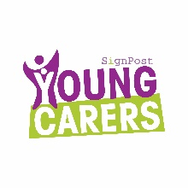
Young Carers
What is a young carer?
A Young Carer is a child or young person who provide care to a family member. The child or “young carer” spends time looking after or helping a member of their family who is unable to take care of everyday tasks themselves without some help. The level of care they provide would usually be taken by an adult and as a result of this they take on responsibility that is inappropriate to their age and development. This may be due to an illness, disability, mental health problems or drug and alcohol issues. This is likely to have a significant impact on their childhood experiences.
The help young carers may give could include shopping, making meals, doing the laundry, or perhaps helping out with childcare, giving medication, or lifting someone up and downstairs. Young Carers may also give time just to be with someone when they need company.
When identified young carers often experience negative impacts on their education and development because of their responsibilities at home.
Who can help me?
Being a young carer or a family member of a young carer can be lonely and confusing. However help is available!
Signpost Stockport for Carers is an independent local charity who have been supporting carers for more than 30 years. If you are a Stockport Carer or caring for somebody living in Stockport a referral can be made to offer support and guidance.
https://signpostforcarers.org.uk/
Telephone: 0161 442 0442

At Westmorland Primary we support young carers by working closely with our families and signposting them to the right services to ensure they have the best support as a young carer.
Tracey Taylor Emily Day
Young Carers Lead Young Carers Champion




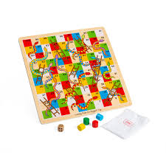
Join us for chat and board games every Monday lunch time.


