Online reading
Please don’t forget to log on to read.
Using:
https://boost-learning.com
Press: 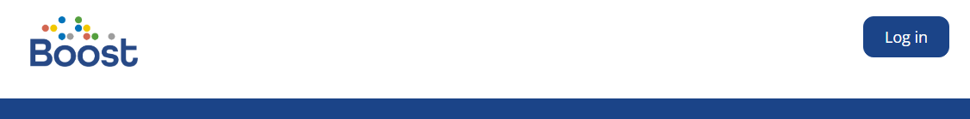
You will see:
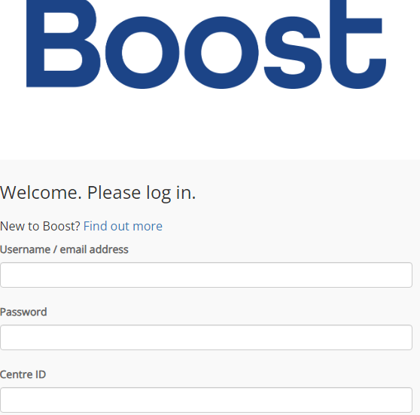
Username: Type your first and last name, lowercase with no space
Password: westmorland1
Centre ID: 179993

You will see your own page, you can change your avatar…
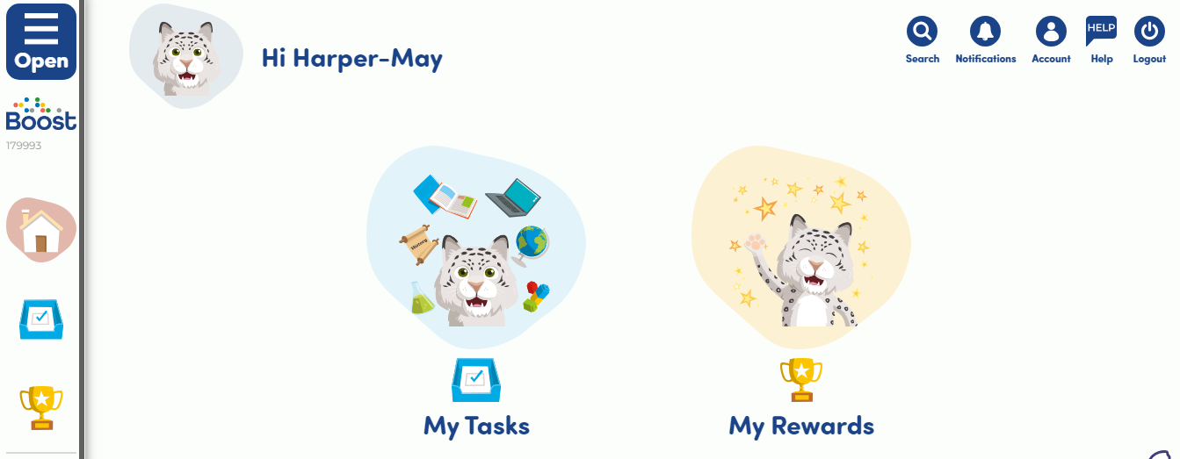
You will have books assigned…
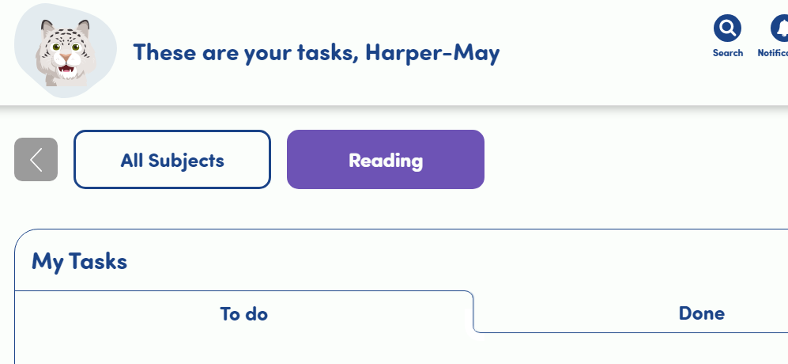
Go to your reading books and enjoy! Don’t forget to answer the questions. You can use this on a phone, ipad or even a laptop alongside your reading books. Have fun!

