My Calm Book

“

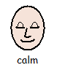


This booklet belongs to: _______________________

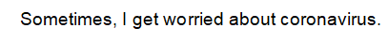
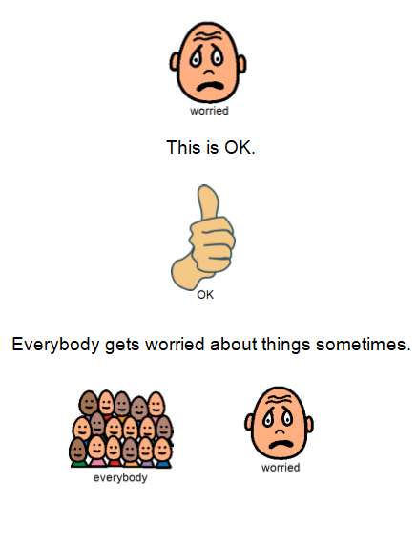
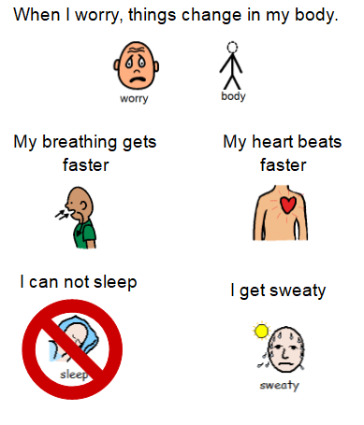

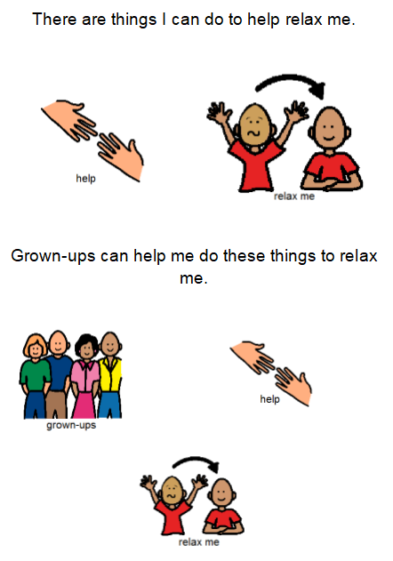

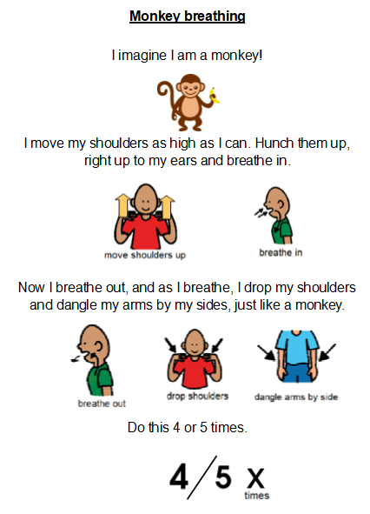
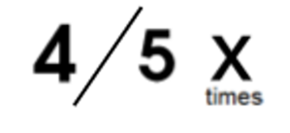

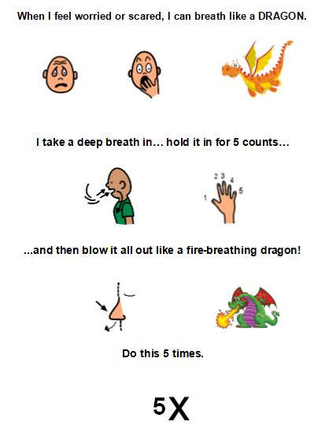

Fire-breathing Dragon

Star Breathing

Start at any ‘breathe in’ side. Hold your breath at the point. Then breathe out. Keep going until you have gone around the whole star. Turning the paper as you go might help!
Hold

Breathe out
Breathe in
Hold

Breathe out
Hold
Breathe in

Breathe out
Breathe in

Breathe out
Breathe in

Breathe out
Hold
Hold
Breathe in

Muscle Relaxation
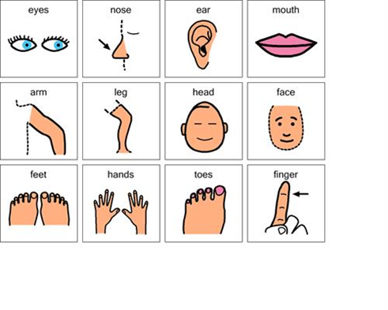
Start at your feet
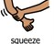
Squeeze the muscles

Slowly let go

Squeeze your legs

Slowly let go

Slowly move up your body
Until you reach the top



The 5 Senses Exercise
1
2
3
4
5

First of all – SLOW down and CALM down
Take 3 SLOW and QUIET deep breaths

5
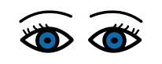
Find 5 things you can SEE
4

Find 4 things you can FEEL

3
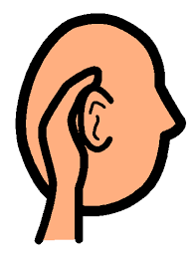
Find 3 things you can HEAR

2
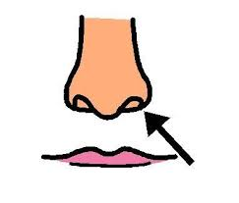
Find 2 things you can SMELL

1

Say 1 good thing about YOURSELF

Distraction and Relaxation Cards

These are distraction cards with tips for when you might feel a little nervous. Perhaps you could pick 2 of your favourites to cut out!

Count the colours in the room you are in

Sing your favourite song

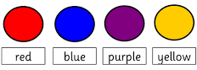
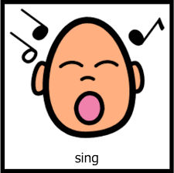

Say out loud: ‘I can do this, I am doing great’

Play a game of i-Spy!

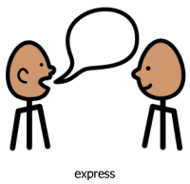

Use your imagination to think of a story

Count backwards from 10

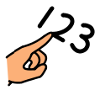
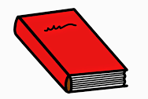

Calming Activity Diary

To relax I like to….

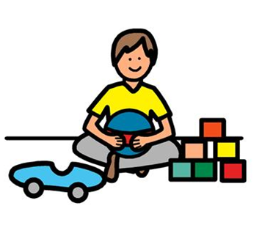
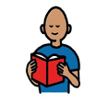
Read a book Play with toys

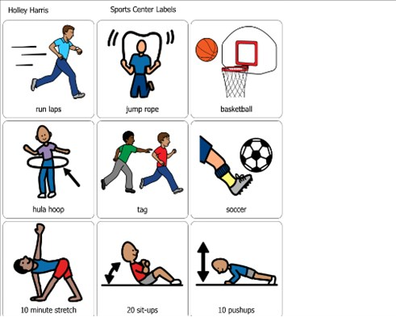
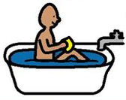
Take a bath Exercise

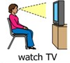
Watch TV Listen to music

You could think of other ideas for what helps you feel relaxed and calm and put them on this table. You could try some while you are home from school!
Date/Time | What are you thinking?  (What is your mind telling you?) | What are you feeling?  (What can you feel in your body?) | What calming activity could you try? | How easy is it to do the strategy?  (Put a circle around the answer)

Easy Hard but I Hard
Did it!
Easy Hard but I Hard
Did it!
Easy Hard but I Hard
Did it!
Easy Hard but I Hard
Did it!
If you are feeling worried, remember these tips…
There are things you can do to help!

You can use the ideas in this booklet to feel calm
It’s ok to be worried
We all feel worried sometimes
Talking to an adult can make you feel better

